Project Design Phase
Solution Architecture
Date | 12 July 2026
Team ID | [Enter Team ID]
Project Name | Smart Lender – Loan Approval Prediction System
Maximum Marks | 4 Marks

Solution Architecture
Solution architecture bridges the credit officer's problem with a concrete, deployable technology solution. It defines the components, their responsibilities, and how they interact end to end — from a raw applicant dataset to a live prediction in the browser.
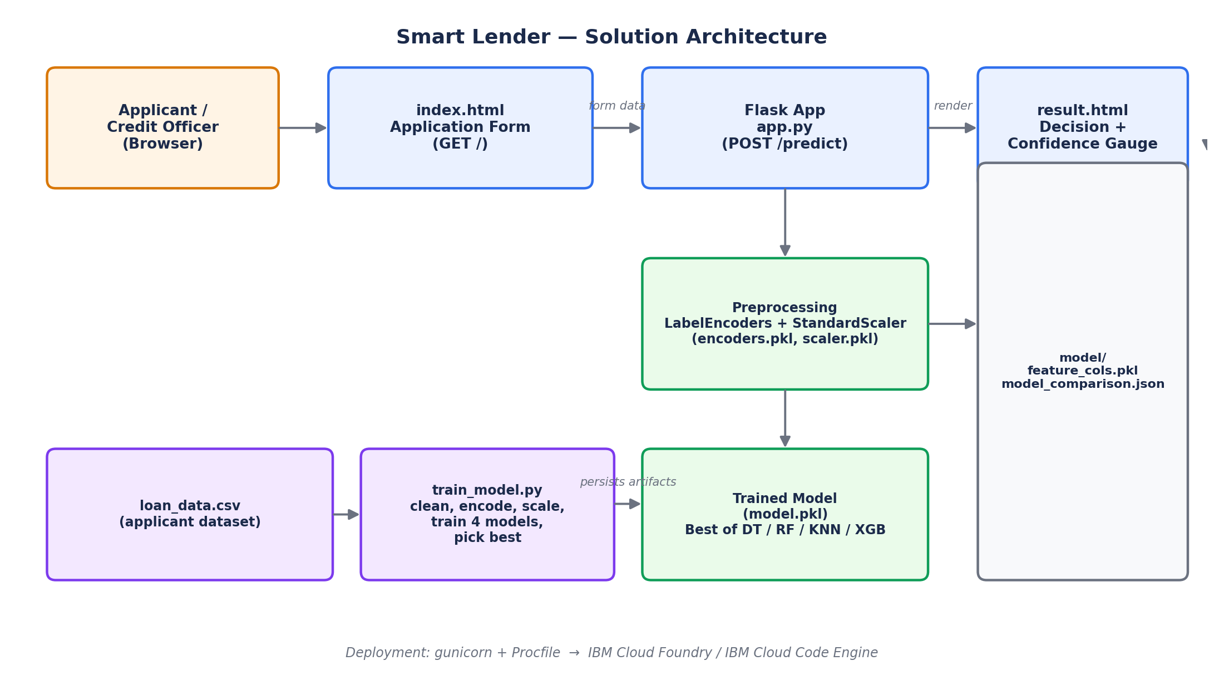

Layer breakdown
Layer | Responsibility | Key files
Presentation | Applicant intake form; renders the decision and confidence gauge | templates/index.html, templates/result.html, static/css/style.css
Application | Flask routes: GET / serves the form, POST /predict encodes input, runs inference and computes gauge geometry | app.py
Preprocessing | Label-encodes categorical fields and scales numeric fields identically at train and serve time | model/encoders.pkl, model/scaler.pkl, model/feature_cols.pkl
Model | Best of four trained classifiers, selected automatically on test accuracy | model/model.pkl (Decision Tree / Random Forest / KNN / XGBoost)
Training Pipeline | Cleans data, trains & compares all four models, persists the winner and its metrics | train_model.py, model/model_comparison.json
Data | Source applicant dataset used for training | data/loan_data.csv, data/generate_data.py
Deployment | Runs the WSGI app in production | Procfile (gunicorn app:app) → IBM Cloud Foundry / Code Engine

Request flow
- The officer opens the app; Flask's GET / route renders index.html with the intake form.
- On submit, POST /predict receives the form, builds a single-row DataFrame, and encodes each categorical field with its fitted LabelEncoder (falling back to the most common class for unseen values).
- Numeric fields are scaled with the fitted StandardScaler, columns are reordered to feature_cols.pkl, and the persisted model.pkl produces a prediction and, where supported, a class probability.
- app.py converts the probability into gauge needle coordinates and arc length, then renders result.html with the decision, confidence, and the applicant's own submitted data.

